**A SRS Document On**

**E commerce Site Amazon**

By

**Satyam Tripathi**

(Software Engineer, Espire Infolabs, 2021)

Approved By:

**ABSTRACT**

**Electronic Commerce is process of doing business through computer networks. A person sitting on his chair in front of a computer can access all the facilities of the Internet to buy or sell the products.**

**Unlike traditional commerce that is carried out physically with effort of a person to go & get products, ecommerce has made it easier for human to reduce physical work and to save time.    E-Commerce which was started in early 1990’s has taken a great leap in the world of computers, but the fact that has hindered the growth of e-commerce is security. Security is the challenge facing e-commerce today & there is still a lot of advancement made in the field of security.**

**The main advantage of e-commerce over traditional commerce is the user can browse online shops, compare prices and order merchandise sitting at home on their PC.**

**For increasing the use of e-commerce in developing countries the B2B e-commerce is implemented for improving access to global markets for firms in developing countries. For a developing country advancement in the field of e-commerce is essential. The research strategy shows the importance of the e-commerce in developing countries for business applications.**

**Table of Contents**  
**Acknowledgements.............................................................................................................   
1. Introduction.....................................................................................................................   
1.1 Goal...........................................................................................................................   
1.2 Need of the application .............................................................................................   
1.3 Scope.........................................................................................................................   
1.4 Platform Specifications – Deployment .....................................................................   
1.4.1 Hardware Specification......................................................................................   
1.4.2 Software Specification.......................................................................................   
2. System Requirement Analysis ........................................................................................   
2.1 Information Gathering ..............................................................................................   
2.2 System Feasibility.....................................................................................................   
2.2.1 Economic Feasibility.........................................................................................   
2.2.2 Technical Feasibility..........................................................................................   
 3. Procedural/Modular Approach................................................................................   
3.1 Shop Products Module.....................................................................................   
3.2 Product Description Module............................................................................   
3.3 Shopping Cart Module.........................................................................................**

**..Class Diagram …………………………………………………………………………………**

**..Use Case Diagram……………………………………………………………………………..**

**..Package Diagram……………………………………………………………………………….**

**..Object Diagram…………………………………………………………………………………**

**..Deployment Diagram…………………………………………………………………………**

**4. Testing……………………………………………………………………………………………**

**4.1. Unit Testing…………………………………………………………………………………..**

**4.2. Integration Testing…………………………………………………………………………**

**4.3. Validation Testing…………………………………………………………………………  
5. Challenges Faced Using E-Commerce Site……………………………………….  
6.Conclusions...................................................................................................................   
7.Limitations ..............................................................................................................   
8. Scope for Future Work............................................................................................   
9. References.....................................................................................................................**

**Acknowledgement**

**A small web-site as this one has required   help from many quarters. We realized this when we ventured into the area of web development. From the beginning everyone co-operated, supported us for which we express our sincere acknowledgement.**

**Training  is  the first  step in  the  practical  field  from  where one learns  how to apply  theory  principles  for  this  the   practical  purposes. To develop a successful website, one needs understanding    and   co-ordination  from  all those who are  directly and  indirectly involved in this.**

**We, the students of Engineering College, find ourselves to be privileged to have golden opportunity to develop website under the guidance of such people without whom designing and developing website successfully would have been just impossible for us. We are thankful to them.**

**We would like to thank all those who have supported us. A person can be successful only when the team and organization for which they are working have unlimited goal of his perseverance. We hereby, like to show our deep gratitude towards our instructor and project in charge all faculty of college helped us very much.**

**We are obliged to them for successful completion of our E-Commerce Project.**

**Last but not the least;**

**Above all, we should not forget the great director of the world,**

**‘The Almighty’; let us thank the Almighty for His inspiration.**

**1 INTRODUCTION**

**Amazon's online retail services allow businesses to sell their products on the same platform as the Amazon retailer, Amazon.com. After creating an account, businesses are able to upload their product inventory, sell their products and capture their payments online. Amazon payment options are available**.

**1.1 Goal**

**1 Shopping has long been considered a recreational activity by many. Shopping online is no exception. The goal of this application is to develop a web based interface for online retailers. The system would be easy to use and hence make the shopping experience pleasant for the users. The goal of this application is**

**•To develop an easy to use web based interface where users can search for products, view a complete description of the products and order the products.**

**• A search engine that provides an easy and convenient way to search for products specific to their needs. The search engine would list a set of products based on the search term and the user can further filter the list based on various parameters.**

**1.2 Need of the application**

**Ecommerce has helped businesses improve their efficiency through streamlining the production and service delivery process. ... E-commerce has also simplified sales and marketing as salespeople can complete sales online, saving time, increasing revenue and enhancing efficiency. Less pollution i.e. People can buy any product or service from any location through internet without traveling from their respective home or workplace. Business associates can contact each other from their locations. It reduces traffic and reduces air pollution and contributes to lessen global warming.**

**1.3 Scope**

* **Selling can be centered around the Global client.**
* **Pre-deals, subcontracts, and supply.**
* **Financing and protection.**
* **Commercial exchanges, requesting, conveyance installment.**
* **Product administration and support.**
* **Cooperative item improvement.**
* **Distributive co-employable working.**

**1.4 Platform Specifications – Deployment**

**1.4.1 Hardware Specification**

* **CPU: for web 1.6 GHz , for web and database 4 x 1,6 GHz CPU.**
* **RAM: 4GB.**
* **Minimum database space: 10GB.**
* **CPU: Quad 2GHz+ CPU.**
* **RAM: 6GB.**
* **Minimum database space: 10GB.**

**1.4.2 Software Specification**

**Cloud computing with AWS  
  
Amazon Web Services (AWS) is the world's most comprehensive and broadly adopted cloud platform, offering over 200 fully featured services from data centers globally.**

**2. System Requirement Analysis**

**2.1 Information Gathering**

**To choose better products for your e-commerce business, you need to gather the right customer information:**

1. **Analyze transactional data. In-demand products are sold products. ...**
2. **Collect social media information. Customers discuss their top purchases on social media. ...**
3. **Gather reviews. ...**
4. **Collect customer feedback.**

**2.2 System Feasibility**

**The system feasibility can be divided into the following sections:**

**2.2.1 Economic Feasibility**

**Ecommerce boosts the economy by increasing productivity, encouraging innovation, and driving better shopping experiences. In addition, ecommerce creates opportunities for protecting the planet, both for forward-thinking sellers and for eco-conscious shoppers.**

**2.2.2 Technical Feasibility**

Today, our employees work in technology enabled environments where the technology is

used to improve processes and assist them doing their daily role, ranging from random

stow and pick through to box sizing algorithms, software that determines the shortest,

most efficient walking route from one place to another and the SLAM process (Scan,

Label, Apply, Manifest), which was developed by Amazon and remains a revolutionary

innovation for customers because it speeds up the packing process and helps ensure

accurate deliveries

A. Rapid technological obsolescence (threat & opportunity)

B. Increasing IT efficiency (opportunity)

C. Increasing cybercrime (threat

Today, our employees work in technology enabled environments where the technology is

used to improve processes and assist them doing their daily role, ranging from random

stow and pick through to box sizing algorithms, software that determines the shortest,

most efficient walking route from one place to another and the SLAM process (Scan,

Label, Apply, Manifest), which was developed by Amazon and remains a revolutionary

innovation for customers because it speeds up the packing process and helps ensure

accurate deliveries

A. Rapid technological obsolescence (threat & opportunity)

B. Increasing IT efficiency (opportunity)

C. Increasing cybercrime (threat

Today, our employees work in technology enabled environments where the technology is

used to improve processes and assist them doing their daily role, ranging from random

stow and pick through to box sizing algorithms, software that determines the shortest,

most efficient walking route from one place to another and the SLAM process (Scan,

Label, Apply, Manifest), which was developed by Amazon and remains a revolutionary

innovation for customers because it speeds up the packing process and helps ensure

accurate deliveries

A. Rapid technological obsolescence (threat & opportunity)

B. Increasing IT efficiency (opportunity)

C. Increasing cybercrime (threat

**Today, our employees work in technology enabled environments where the technology is used to improve processes and assist them doing their daily role, ranging from random stow and pick through to box sizing algorithms, software that determines the shortest, most efficient walking route from one place to another and the SLAM process (Scan,**

**Label, Apply, Manifest), which was developed by Amazon and remains a revolutionary innovation for customers because it speeds up the packing process and helps ensure accurate deliveries**

**A. Rapid technological obsolescence (threat & opportunity)**

**B. Increasing IT efficiency (opportunity)**

**C. Increasing cybercrime (threat)**

**3. Procedural/Modular Approach**

**Following are all the modules designed for the Online Shopping System.**

**3.1 Shop Products Module**

**An Amazon Stores is a free premium content offer on Amazon that vendors can use to exclusively showcase a curated collection of products and elevate their brand.**

**These stores provide an enhanced brand-centric shopping experience on Amazon on both desktop and mobile platforms.**

**Amazon Stores elevate the shopping experience by:**

* **Capitalizing on internal and external traffic sources**
* **Potential to boost organic ranking on Amazon and increase sales volume**
* **Ability to promote new products to pre existing customers**
* **Opportunity to introduce your brand to new audiences**
* **Giving users a better mobile experience with your brand on Amazon**

**Amazon Stores give brands the ability to maintain their brand identity on the world’s largest online marketplace. All of those benefits alone are enough reason to invest in Amazon Stores.**

**But on an even bigger scale, more brands are excited about Stores because this means they no longer have to worry about losing their brand identity in a competitive online marketplace.**

**3.2 Product Description Module**

1. **Preparation:**
2. **Record online store details.**
3. **Choose a product.**
4. **Decide on a price.**
5. **Calculate shipping details.**
6. **Take pictures to highlight your product.**
7. **SEO:**
8. **List potential keywords**.

**3.3 Shopping Cart Module**

**What type of cart does amazon use?**

**Amazon Dash Cart**

**What is Amazon Dash Cart? It's a new smart shopping cart that makes a quick grocery trip even quicker by allowing you to skip the checkout line. How does Amazon Dash Cart work? The cart uses a combination of computer vision algorithms and sensor fusion to identify items you put in the cart.**

Procedural/Modular Approach Following are all the modules designed for the Online Shopping System. 4.3.1 Shop Products Module This module starts when the user visits the home page or when a user

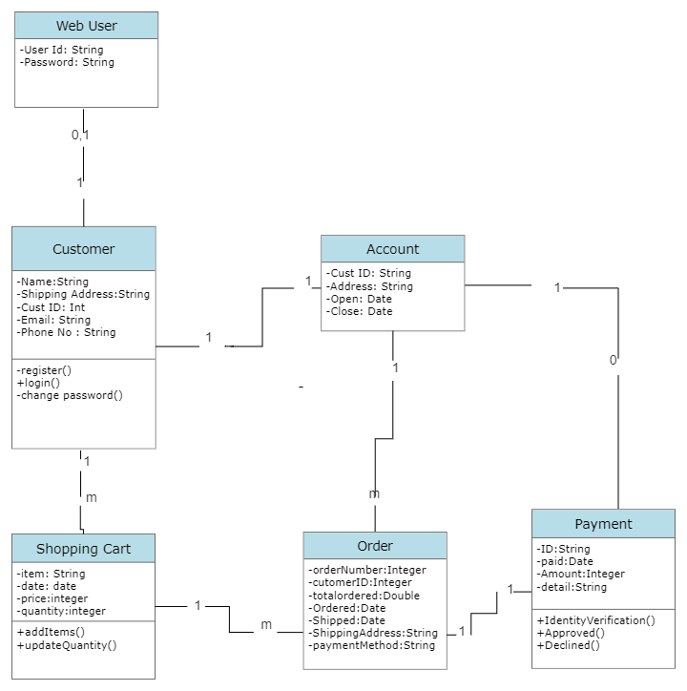

**Class Diagram Of an E-Commerce Site**

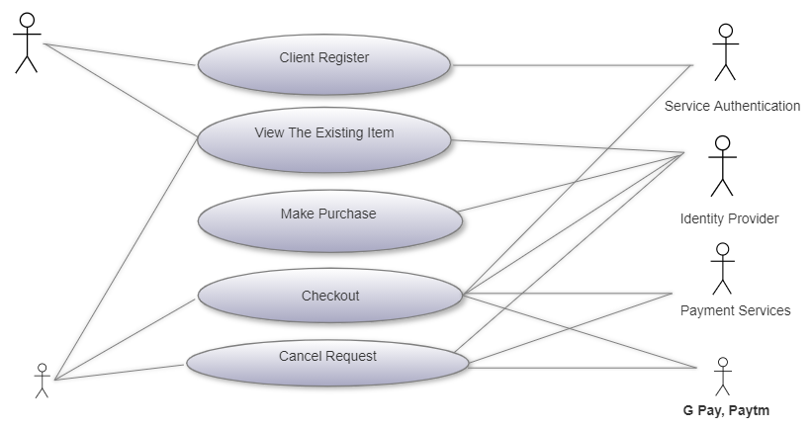

**Use Case Diagram Of an E-Commerce Site**

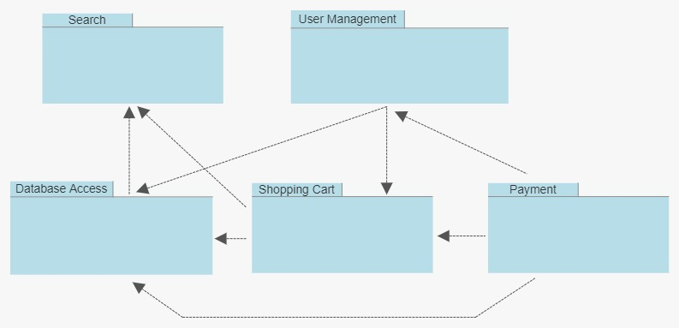

**Package Diagram**

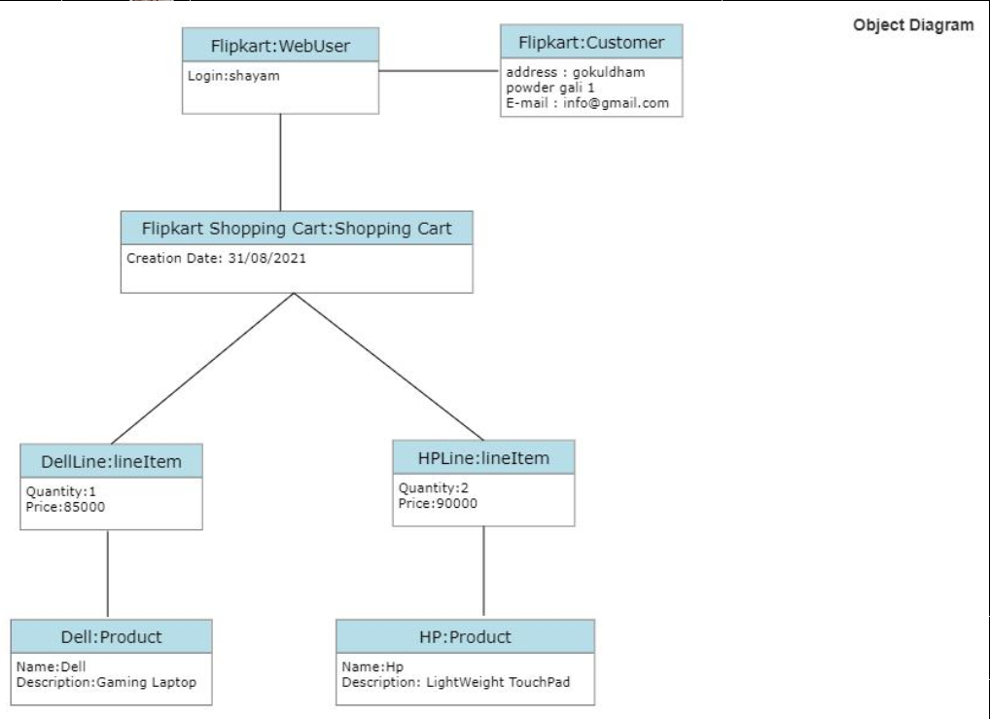

**Object Diagram**

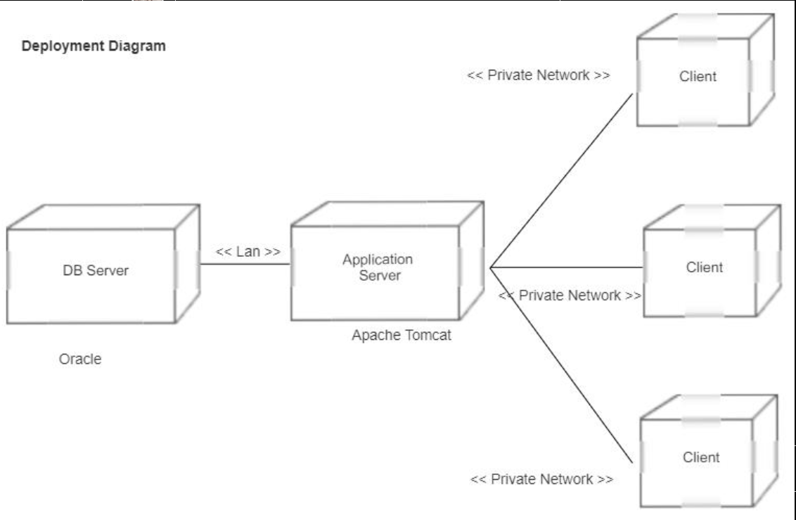

**Deployment Diagram**

**4.TESTING**

**Software Testing is an empirical investigation conducted to provide stakeholders with information about the quality of the product or service under test, with respect to the context in which it is intended to operate. Software Testing also provides an objective, independent view of the software to allow the business to appreciate and understand the risks at implementation of the software. Test techniques include, but are not limited to, the process of executing a program or application with the intent of finding software bugs. It can also be stated as the process of validating and verifying that a software program/application/product meets the business and technical requirements that guided its design and development, so that it works as expected and can be implemented with the same characteristics.**

**Software Testing, depending on the testing method employed, can be implemented at any time in the development process, however the most test effort is employed after the requirements have been defined and coding process has been completed.**

* 1. **Unit Testing:**

**The primary goal of unit testing is to take the smallest piece of testable software in the application, isolate it from the remainder of the code, and determine whether it behaves exactly as you expect. Each unit is tested separately before integrating them into modules to test the interfaces between modules. Unit tests are typically written and run by software developers to ensure that code meets it design and behaves as intended. Its implementation can vary from being very manual (pencil and paper) to being formalized as part of build automation.**

* 1. **Integration Testing:**

**Integration testing, also known as integration and testing (I&T), is a software development process which program units are combined and tested as groups in multiple ways. Integration testing can expose problems with the interfaces among program components before trouble occurs in real- world program execution. There are two major ways of carrying out an integration test, called the bottom-up method and the top-down method. Bottom-up integration testing begins with unit testing, followed by tests of progressively higher-level combinations of units called modules or builds. In top-down integration testing, the highest-level modules are tested first and progressively lower- level modules are tested after that. In a comprehensive software development environment, bottom-up testing is usually done first, followed by top-down testing.**

* 1. **Validation testing:**

**At the validation level, testing focuses on user visible actions and user recognizable output from the system. Validations testing is said to be successful when software functions in a manner that can be reasonably expected by the customer. Two types of validation testing**

* **Alpha testing is simulated or actual operational testing by potential users/customers or an independent test team at the developers' site. Alpha testing is often employed for off-the-shelf software as a form of internal acceptance testing, before the software goes to beta testing.**
* **Beta testing comes after alpha testing. Versions of the software, known as beta version, are released to a limited audience outside of the programming team. The software is released to groups of people so that further testing can ensure the product has few faults or bugs. Sometimes, beta versions are made available to the open public to increase the feedback field to a maximal number of future users**

**5. Challenges Faced Using E commerce Site-**

* **Cyber & Data Security. When it comes to e Commerce, one of the biggest challenges faced is security breaches. ...**
* **Online Identity Verification. ...**
* **Attracting the Perfect Customer. ...**
* **Customer Loyalty. ...**
* **Converting Shoppers into Paying Customers. ...**
* **Competition & Competitor Analysis. ...**
* **Price & Shipping. ...**
* **Product Return & Refund Policies.**

**6.Conclusion-**

**E-Commerce has undeniably become an important part of our society. The successful companies of the future will be those that take E-Commerce seriously, dedicating sufficient resources to its development. E-Commerce is not an IT issue but a whole business undertaking. Companies that use it as a reason for completely re-designing their business processes are likely to reap the greatest benefits. Moreover, E-Commerce is a helpful technology that gives the consumer access to business and companies all over the world.**

**7.Limitations-**

* **Security. The biggest drawback of e-commerce is the issue of security. ...**
* **Lack of privacy. Many websites do not have high encryption for secure online transaction or to protect online identity. ...**
* **Tax issue. ...**
* **Fear. ...**
* **Product suitability. ...**
* **Cultural obstacles. ...**
* **High Labour cost. ...**
* **Legal issues**

**8.Future Scope –**

**Information suggests the future of internet lies in mobiles. Experts say that 582 million people in India will use the Internet by 2019 and 70% of them will admittance the Web on mobile. This will reason to switch to app only model. Flipkart, Snapdeal, Amazon comes from users in small cities village and towns**

**In terms of future of e-commerce in the 21st century, experts predict the promising and glorious figures. In the foreseeable future, e-commerce will be confirmed as the major tool of sale for the goods and services. Successful e-commerce will become the notion which will be inseparable from the web because e-shopping is becoming more and more popular and natural. Thus, prevailing to future trends, e-commerce will have huge potential growth in sales and promotion.**

**Each year, there is a continuous growth in e-commerce deals. The volumes of sales for online store are much higher than the brick and mortars. To the present day, the internet sales boom the foundation for magnificent e-commerce future. To attract more customers, owners will not only have to increase the number of services available to them but also have to pay more attention to such elements like design, good presentation, etc.**

**9. References-**

**Wikipedia**

<https://en.wikipedia.org/wiki/Amazon_(company)>

<https://www.smarthint.co/en/futuro-do-ecommerce/>

<https://www.robabdul.com/business/feasibility-study-cost-benefit-analysis-for-your-new-ecommerce-web-site/>